

Health, Safety and Fire and Building Management Policies

July 2025

Health, Safety and Fire and Building Management Policies
July 2025

Contents:

1.0 Summary Statement

- Health and Safety Risk Assessment

- Fire Safety

  - Fire Instructions and Drills
  - General fire Precautions
  - Evacuation procedure
  - Maintenance and Testing of Fire Precautions

- General Health and Safety

  - First Aid Provision
  - Accidents
  - Children’s Safety
  - Food Hygiene and the Kitchen
  - Electrical Safety
  - Outside Play Area
  - Minibus Usage
  - Noise
  - Eyes
  - Working at height
  - Manual Handling
  - Lone working

- Building Management

  - Equipment
    - Chairs
    - Access Equipment
    - The Stage
    - Storage
    - Insurance
  - Building Use
    - Keys
    - Water and Showers
    - Sleepovers
    - Bouncy castle
    - Cleansing and Rubbish
    - Toilets
    - Heating
    - Smoking
    - Signage
  - Events
    - Bookings
    - External Bookings
    - Work Days
    - Special and one-off events / new events
    - Pandemic Influenza

Appendix A Display Screen Assessment Check sheet

Appendix B Responsibilities Check List

Appendix C Briefing Checklist and Personal Declaration

Comments on these policies should be passed in writing to the church’s Health and Safety Officer or Administrator.

Throughout these policies certain people are referred to by job title. The people currently fulfilling these jobs are as follows:

Pastor Josh Parmar
Elders Stuart Hardisty, Annabel Chaloner, Martin Pearce
Deacons Judy Davies, Justin Chaloner, Dave Garner
Health and Safety Officer Andy Mellor and Tom Grove
Administrator Judy Davies
Social Media Manager Luke Tattersall
Children, Youth & Families Worker Laura Twell
Cleaner Oliver St Hilaire
Fire Officer Henry Forrest
Acting Treasurer Mark Halliday

1.0 Summary Statement

The church recognises and accepts its responsibilities for providing, so far as is reasonably practicable, a safe and healthy environment with a view to ensuring the health, safety and welfare of all those who use the church premises.

The church will, therefore, take all necessary steps within its power to meet its responsibilities so far as is reasonably practicable by, among other arrangements:

- maintaining the church premises in a condition that is safe and without risk to health and providing and maintaining means of access to and egress from it that are safe and without such risks;
- providing and maintaining furnishings and equipment which are safe and without risks to health;
- assessing the risk to the health and safety of those who use the church premises;
- ensuring the safety and absence of risks to health in connection with the use, handling, storage and transport of articles, equipment, furniture and substances;
- the provision of such information, instruction, training and supervision as is necessary to ensure the health and safety of those who use the church premises;
- the provision and maintenance of a proper environment for the church’s employees, leaders, helpers and volunteers that is safe, without risks to health, and adequate as regards facilities and arrangements for their welfare;
- arranging for suitable induction programmes and training; consulting, where necessary, with all employees, leaders, helpers and volunteers on the effectiveness and implementation of this policy; and any necessary changes.
- ensuring that adequate funds and resources are made available for carrying out this policy.

The church’s charity trustees have overall responsibility for health and safety. They have given responsibility for the fulfilment of this policy to the church’s Health and Safety Officer but subject to the charity trustees will be responsible for carrying out the implementation of the church’s policy and for the issue of supplementary policy statements where this may be necessary.

The Health and Safety Officer will:

- carry out appropriate risk assessments (these to be reviewed annually) of the church’s premises and activities and report to the church’s charity trustees as necessary;
- co-ordinate the implementation of the church’s Health and Safety Policy (including Fire Safety);
- carry out investigations of any accidents and recommend measures for preventing their recurrence;
- ensure that accident and other appropriate records are maintained and returned to the appropriate bodies;
- ensure that all appropriate arrangements are made to provide for first aid;
- ensure that all food safety legislation is complied with;
- arrange safety training courses, as may be necessary or desirable, so that specific legal requirements are adhered to and that any changes in such requirements are complied with and communicated to employees, leaders, helpers and volunteers as necessary;
- ensure that, where necessary, all relevant safety regulations are prominently displayed, that all emergency procedure notices are properly exhibited and clearly visible at all times;
- ensure that access to and from emergency exits and fire equipment are not impaired and that corridors and stairs are kept free from obstructions other than of a temporary and partial nature.

All volunteers, ministers, employees, leaders, and helpers will:

- take reasonable care of their health and safety, and of the health and safety of other persons who may be affected by a person’s act or omissions while working or helping.
- as regards any duty or requirement imposed on the church or any person by or under any of the relevant statutory provisions, co-operate with the church so far as is necessary to enable that duty or requirement to be performed or complied with;
- ensure that they shall not intentionally or recklessly either interfere with or misuse anything provided in the interest of health, safety or welfare, in pursuance of any of the relevant statutory provisions;
- make themselves familiar with and conform to the Health and Safety Policy of the church at all times;
- observe all safety rules, procedures, and codes of practice at all times, and in particular be fully conversant with the procedures to be followed in the event of a fire or any other emergency;
- conform to all the food safety regulations that are applicable to themselves;
- co-operate with the church to enable it to carry out the duties and requirements under the provisions of all health and safety legislation, including participating in any initial or other training if called upon to do so;
- report to the church’s Health and Safety Officer all accidents or hazardous occurrences or dangers whether persons are injured or not as soon as is reasonably practicable;
- ensure that all working equipment and materials used by them are in a safe and serviceable condition and that no cables or wires are left in such a position as to be likely to cause anyone to trip;
- have regard to the possible consequences of their actions on the health, safety and welfare of all those persons who at any time and for whatever purpose may or will use the church premises.

2.0 Health and Safety Risk Assessment

Churches have a legal duty to assess risks which exist on the premises and to reduce them as far as reasonably practicable. A risk assessment of each area of the church is to be undertaken by the Health and Safety Officer once a year, or sooner if there are significant changes to any areas in the interim.
The current risk assessments are kept electronically on the church’s One Drive system.

- Fire Safety

The Regulatory Reform (Fire Safety) Order came into effect on 1 October 2006. It reforms the law relating to fire safety in non-domestic premises. Responsibility for complying with the Fire Safety Order rests with the diaconate as a group.

3.1 Fire Instructions and Drills

All persons at work and all newly appointed staff shall be instructed and trained to ensure that they understand the fire precautions and the action to be taken in the event of a fire. The training shall be appropriate to their responsibilities in an emergency and shall be based on the fire safety evacuation procedure (see 3.3). A copy of the written instructions shall be given to each person. The instruction and training shall cover:
- the action to be taken on discovery of a fire;
- the action to be taken when the alarm is activated;
- operation of the fire alarm, location of fire alarm call points and the indicator panel;
- the method of calling the Fire Service;
- the correct method of operation and the location of fire fighting equipment;
- the purpose of fire resisting doors and their location in the building;
- familiarity with the escape routes;
- evacuation of the building and location of assembly points.

When parts of the premises are occupied by persons who have a disability which would prevent them from using the same means of escape as an able-bodied person, efficient arrangements shall be in place to ensure their safe evacuation in an emergency.
Lifts shall not be used for this purpose unless authorised by the fire service.
All persons at work shall receive tuition by a competent person not less than once in every period of 12 months. This shall include evacuation drills (including the operation of fire alarms) based on the assumption that, where appropriate, one escape route may be affected by fire.
For employees for whom English is not a first language, written instructions shall be provided in their own language.
All persons on regular duties outside normal working hours shall also be included in the instructions and training.
All outside contractors and their employees shall, prior to commencing work, be made familiar with the routine to be followed in case of fire.
Details of the instruction and training shall be recorded on the record sheet contained in the filing cabinet in the office.

3.2 General Fire Precautions

- Water fire extinguishers (Red) should be used for all wood, paper and general fires
- Carbon Dioxide fire extinguishers (Red with Black marking) should be used for all electrical fires.
- The areas around the fire exits and walkways must be kept clear of all obstructions (including cables).
- All fire doors should be kept shut and passageways kept clear at all times.
- Fire Evacuation notices are displayed around the building and users should familiarise themselves with the information shown.
- A register should be taken at any children’s activity (ie for under 18s). This list must be kept safe by the leader of the activity and used for a roll call if the building needs to be evacuated.
- No candles or naked flames may be used in the building except with the permission from the Pastor or deacons.
- The maximum capacity for the hall is 275 seated or 400 standing.

3.3 Evacuation Procedure

Fire Drills will be organised by the Fire Officer and held at least twice a year.

If you discover a fire ALWAYS EVACUATE THE BUILDING FIRST:

- Sound the fire alarm
- Evacuate the building. Do not use the Lift
- Call the Fire Brigade if it is safe to do so.
- Any persons upstairs who cannot manage the stairs should be taken to the recesses at the top of either stairwell to await rescue by the Fire Brigade. These must be kept clear at all times.
- If possible close all doors and windows in the immediate vicinity of the fire.
- As the building is evacuated, close doors as you go.
- After the evacuation has begun, and if it is safe to do so, tackle the fire with the fire equipment provided.
- The building must remain unlocked.

If you hear the Fire Alarm:

- Make your way out of the building. Do not run and do not take any belongings with you
- After leaving the building make your way to the assembly point by Cathays Methodist Church.
- Do not leave the assembly point until authorised to do so.
- Youth Workers should take a roll call for the children in their care.
- When the Fire Officer arrives inform them of any missing people and their last known whereabouts.
- Do not re-enter the building until the Fire Officer has said it is safe to do so.

Notices containing the text of the above two items along with a map showing fire exits and the location of the assembly point should be displayed throughout the building.
If you suspect there is a fire in a closed room check for signs of smoke from the door and then gently touch the door. If you see smoke or the door feels warm do not open the door – evacuate the building and call the fire brigade.

3.4 Maintenance and Testing of Fire Precautions

The ‘Fire alarm and fire extinguishing system’ book’ contains information relating to the regular testing of each system. (Churches Fire & Security)

4.0 General Health & Safety

4.1 First Aid Provision

A First aid box is located in the kitchen.
The Health and Safety officer or Administrator should be informed of any items used or of any suggestions for items to be added to the kits.
A small first aid kit should be taken on all trips away from the building by church groups. This may be booked by speaking to the Administrator.
The leader of each church activity should carefully consider the need for one of the leaders to be a qualified first aider. The church will pay for volunteer/staff members to go on a training course.

  - Accidents

All accidents, however minor, must be recorded in the accident book (kept by the white First Aid Cabinet in the kitchen) the completed page should be placed in the black post box in the lobby.
Any accidents involving children (under 18s) must be reported both verbally and in writing to the parents as detailed in the church’s Safeguarding Policy.
Any serious accidents (eg requiring hospital treatment) should be reported immediately to the Pastor or a Deacon and the church’s Administrator or Health and Safety Officer. They should be phoned at home at whatever time if necessary.
All accidents should be reviewed and all practicable steps taken to prevent a re-occurrence. This should be done by the Health and Safety Officer and Administrator and for serious accidents should also include the Pastor.
If appropriate, accidents should be reported immediately to our insurance company (BU).

4.3 Children’s Safety – refer to Safeguarding Policy

Parents are responsible for their children at all times whilst in the building. They should keep them within sight and under control.
The only exception is when the children are in an organised activity (crèche, children’s work etc). At this point the leaders of the activity take responsibility for the children in their care.
A register should be taken at any children’s activity. This list must be kept safe by the leader of the activity and used for a roll call if the building needs to be evacuated.
For Parent and Toddlers groups the parent or adult who brings each child must stay with their child at all times and take responsibility for their children at all times.
When preparing for a children’s activity, the activity leaders should carefully consider:
- Locking certain doors to avoid them being opened suddenly and catching children who may be behind the doors.
- Blocking access to “dangerous” areas of the church. This may include access to areas that are “safe” for adults, but not for children (eg the kitchen). The stage in the hall and the storage areas should be regarded as “dangerous” areas for children.
- Slipping and tripping hazards such as loose carpets or cables. These should always be taped down or blocked off.
- Ensuring that chairs stacked in the room are no more than 5 high.
- Making sure tables are not stacked upside down on top of one another, so that no table legs are in the air.

4.4 Food Hygiene and the Kitchen – refer to food hygiene guidelines

All people who regularly prepare food for church activities or using the church’s facilities should be aware of the current regulations regarding food hygiene and have a food hygiene certificate.
Food should not be left in the fridge, unless you know it will be used, in which case it should be labelled and dated accordingly. Don’t leave it “Just in case”.
The kitchen should be left clean and tidy after use, with everything put away in the proper cupboards.
No under 18s should go in the kitchen without consent from a parent or guardian and with an adult present, especially if there is food preparation. No more than two under 18s should be in the kitchen at any one time, other than for agreed youth/children’s work activities. Children aged 16 and over may serve in the kitchen, provided there is adult supervision at all times.
For any church event where visitors may be present, there is to be a nominated supervisor with a food hygiene certificate.

4.5 Electrical Safety

All electrical items used must have undamaged cables and plugs. If any cable is at all frayed or if it is pulling away from its connection at the plug or the appliance it must be repaired before use. Similarly, if the plug is in any way cracked or damaged it must be repaired before use. Repairs should be passed to the Health and Safety Officer.
Electrical equipment requires visual inspection on a regular basis by a competent person to ensure the safety of these items. All earthed equipment, and most leads and plugs, should also have a regular electrical test, particularly when a fault is suspected or after a repair.
Owners of personal electrical equipment brought onto the premises are responsible for its safe operation.
To reduce the risk of trips and falls, cables must be run around the doors, taped down or placed under a rubber cover.
Under no circumstances should any electrical equipment of any kind be placed within 2 metres of the open baptistery and people in the water should never use microphones with electric leads.
A routine check of all electrical equipment should be undertaken by a competent person every year and should include looking for any wear and deterioration, missing parts, correct labelling and operation of test buttons etc
A full ‘inspection and test’ of the system should be carried out every 5 years by a suitably qualified professional who should be an NICEIC registered contractor.

4.6 Outside Play Area

The area should be kept clear at all times as it is a fire exit route.
The gates should be kept unlocked to provide egress. Care should be taken when opening them, as they open outwards, so that no-one is knocked over by the gates

  - Minibus Usage

The policy for minibus usage for children’s activities is documented in the church’s Safeguarding Policy.
All minibuses used should have seatbelts. The driver should be an experienced driver and should take special care if they are not used to driving minibuses.

4.8 Noise

If you are undertaking an activity that involves sustained loud noises ear protection should be worn by anyone within range of the noise. Windows and doors may need to be closed during loud worship out of consideration for our neighbours.

4.9 Eyes

All staff who use a computer as part of their everyday work may claim the cost of an annual eye test from their employer.
All staff who use a computer should complete the Display Screen Assessment Form see Appendix A.
All staff who work in areas with risk of foreign objects entering their eyes (eg soldering, welding or drilling) should wear eye guards.

4.10 Working at Height
The Work at Height Regulations 2005 apply to all work at height where there is the risk of a fall liable to cause personal injury. The overriding principle is that we must do all that is reasonably practicable to prevent anyone from falling. Where possible the following applies:

- Avoid work at height where possible
- Use work equipment or other measures to prevent falls where working at height can not be avoided
- Where the risk of a fall cannot be eliminated use work equipment or other measures to minimize the distance and consequences of a fall should one occur.

Where anyone is working at height the following MUST apply;

- All work at height must be properly planned and organised and methods approved by the Health and safety officer prior to work at height taking place
- Those involved in work at height must be competent
- The risks from work at height must be assessed and appropriate work equipment must be used
- The risks from fragile surfaces (such as glass or smooth slate) are properly controlled
- Equipment for work at height is properly inspected and maintained.

For further information on working at height please seek advice from the Health and Safety Officer.

4.11 Manual Handling
Care should be taken in the lifting and moving of heavy items.
If you do not feel that you can move the load safely, request assistance from others.
A sack truck is available for moving heavy items.
Care must be taken when moving the bouncy castle, the stage blocks, the baptistery covers and any other heavy items of plant or equipment.

4.12 Lone Working
Lone worker is to refer to any paid employee, volunteer or member who visits people in their home as part of a pastoral responsibility. This is likely to include the pastor and other staff. On occasion, this may also include deacons or other members of the church.

Lone working is used when previously mentioned workers are in the building alone, or being a lone worker when other users of the building – church members or paying members of the community- are present in a different part of the building.

Care should be taken when working alone in the building. Where possible a minimum of two if undertaking work in a paid or voluntary capacity. Repairs should not be undertaken alone, or if nobody knows that someone is in the building. This is especially important if working at height.

All external doors should be locked when in the building to prevent access by intruders. On leaving, all doors that have been opened should be checked that they are closed properly.

If visiting people in their own homes, consider risk factors such as other family members, friends, alcohol/drug misuse, physical environment. Pastoral care may need 2 people, or a rearrangement of home visit if a visit would put worker/volunteer at personal risk. For example, visiting known alcoholics could pose a serious risk as behaviour is often unpredictable and difficult to diffuse.

If working alone, ensure that somebody knows where you are and what time you plan to return and arrange to telephone to advise that you have got home safely.

A particular risk is for anyone responding to the church office doorbell as there is no way of telling who is at the door or why. Current good practice is for members to arrange appointments where possible, and confirm regular events in the diary. Office staff often bring diary downstairs for ad hoc visits from members of the public wishing to book the building for events. Carrying a mobile phone at all times is recommended.

In the event of a visitor becoming aggressive and being unable to calm that person down to a point that they will leave, make your way to the stairs, or lock self in the lounge and phone the police to request assistance.

5.0 Building Management

5.1 Equipment

5.1.1 Chairs
When chairs are put out for an event there should be wide corridors (at least one metre) to allow easy escape routes.
Chairs in the main meeting room should be neatly stacked in the cupboard after use and the remainder placed around the hall.
Chairs in the main hall and room 1 should be stacked in piles of no more than five, other than when in the chairs’ cupboard. Chairs in other rooms should be stacked to a suitable height.
When moving the chairs, do not stack more than 5 high on the trolley.
The maximum capacity for the hall is 275 seated or 400 standing.

5.1.2 Access Equipment
Ladders should be examined before use to ensure they are in good condition.
They should be secured so they cannot slip, usually by tying them at the top.
The ladder should be angled to minimise the risk of slipping outwards and as a rule of thumb needs to be ‘one out for every four up’.
Do not overreach: A ladder should not be used to work from if an alternative method can be used (ie scaffold tower)
The scaffold tower should be erected in accordance with the instructions and by trained persons only.
Under no circumstances should any access be gained to the roof without prior permission from the Health and Safety officer

5.1.3 The Stage
The stage should be kept tidy, especially for events.
A minimum of two persons are needed to open and close the Baptistery.
Children should be kept off the stage at all times unless under strict supervision.
All power should be turned off on the stage, before the roller shutters are closed.
Care should be taken during the closing of the roller shutter door to ensure that there are no obstructions.

    - Storage
Storage areas are provided throughout the building and all equipment should be put away after use.
The tops of cupboards should be kept clear.
Stage Blocks must always be stored flat.
Any other items that could fall over and injure anyone or cause damage must be stored flat or with other precautions.
Storage areas should be kept tidy at all times.
Hazardous materials, cleaning supplies and paints should be locked away, currently in room 7 or the shed.

5.1.5 Insurance
The Treasurer should be informed of all new items purchased so they can be added to the insurance policy.
All personal items brought to the church should be insured personally.
All damages should be reported to the Treasurer who will arrange for a claim to be made. The damage should also be recorded in the maintenance book in the kitchen.

5.2 Building Use

5.2.1 Keys and swipe cards
Keys are issued to staff of the church and various other leaders. These keys are for personal use and may not be lent to any other person, whether a church member or not, without the authorisation of the Administrator. Spare sets of keys are kept by the Administrator, which may be borrowed. The Administrator keeps a complete list of all keys issued. In the event of loss of keys/swipe card, please advise the administrator so that the card may be cancelled.
Young people from the church may only use the building with adult supervision.
The building must be locked by the last person to leave – all fire exits and windows to be checked.

5.2.2 Water and Showers
The showers must be run once a week for 5 minutes to avoid the build up of legionella bacteria.
Care should be taken with the hot water taps for the sinks in the toilets. The water can get very hot and can scald.

5.2.3 Sleepovers
Sleepovers must be agreed by the Administrator at least 24 hours prior to the event occurring.

5.2.4 Bouncy Castle
The bouncy castle should be supervised by an adult at all times.
Due to insurance restrictions, persons over the age of 12 are not permitted on the bouncy castle.
Care should be taken to ensure that older children don’t ‘bounce into’ younger children, for example by allocating different time slots to different age groups.
Full bouncy castle guidelines are available from the Administrator and should be followed whenever the bouncy castle is used.

5.2.5 Cleaning and Rubbish
A cleaner is employed to clean central areas of the building throughout the week.
The other areas of the church (store rooms and offices) should be cleaned periodically by the people who use them.
All users of the church are expected to clear up any mess they create, ie if an area needs hoovering after use you are expected to do it, not leave it for the Cleaner.
Food rubbish should be placed into the kitchen food bin. Other rubbish should be sorted in accordance with the signage into appropriate recycling bins and general rubbish. As part of the kitchen closing checks each day, the rubbish should be placed in the bin store outside.
Rubbish is collected on Wednesday morning and rubbish should be put out on Crwys Road, in line with the local authority collection regime.

5.2.6 Toilets
The toilets are cleaned twice a week by the cleaner.
There is a sanitary bin in the ladies’ toilets, which is emptied monthly.

5.2.7 Heating
The heating is controlled by a timer switch, which has different programmes for each day of the week. If you think the programme should be changed please inform the Deacons.

5.2.8 Smoking
Smoking is not permitted in the church centre.

5.3 Events

5.3.1 Bookings
All bookings for the church must be made by contacting the Administrator. The booking can then be placed in the diary and a spare set of keys issued if necessary. In all cases booked events will take priority over un-booked events.
There is a “leave it better than you find it” policy regarding rooms in the church. You should expect to have to set up for your event and you are expected to leave the room in a tidy state after your event. If you find the room in an unacceptable state you should inform the Administrator. You can expect to be contacted by the Administrator if you leave the room in an unacceptable state.

5.3.2 External Bookings
All external hirers should hold current public and (if appropriate) employer’s liability insurance. The external hirer is also responsible for managing all Health and Safety issues arising from their activities during the duration of their booking.

5.3.3 Work Days
Occasionally there will be “spring cleans” or other workdays in the building.
If there are more than 4 people, there should be a designated supervisor who shall be responsible for a simple Risk Assessment for each team and care should be taken not to give unskilled volunteers inappropriate tasks.

5.3.4 Special and One-Off Events / New Events
A careful consideration of all health and safety details of new events should be undertaken before the event starts. Unless someone specific is appointed for the health and safety aspects of an event, the leaders of the event are responsible for health and safety.

5.3.5 Pandemic Influenza
We need to be prepared for the particular issues that will arise in the event of a flu pandemic occurring. The Government recognizes the role that churches can have in supporting those that are affected by and outbreak. If a pandemic occurs churches will need to take steps to try and ensure that their services and activities do not contribute to the spread of the virus. More information can be found at http://www.communities.gov.uk/publications/communities/influenzapandemic

Appendix A - Display Screen Equipment Risk Assessment

Name of User:
Location of workstation:
Assessor:
Date of assessment:
Any further action needed? Yes/No (If ‘Yes’, see Section 3)

Section 1 – Pre-Assessment Questionnaire (to be completed by the User)

You have been given this form because you are a display screen equipment (DSE) user as defined by the DSE Regulations. The purpose of the form is to assess whether your workstation is comfortable and can be adjusted to meet your particular needs or whether some action is necessary to make it do so. Please complete Section 1 of the form and return it to your Line Manager who will arrange for an assessor to visit you to complete the assessment (Sections 2 + 3).

Describe your computer use? Tick the appropriate boxes
I work: |  |  | I use the computer: |  |  | I use the computer: |  |  | I use the computer:
Full-time |  |  | Most days |  |  | More than  5 hours per day |  |  | Near continuously for an hour or more
Part-time |  |  | Some days |  |  | Less than  5 hours per day |  |  | On and off

Please answer the questions by putting a tick in either the YES or NO box. If you answer NO to any of the questions, please explain the problem in the space provided and suggest a solution if you can.

1 CHAIR |  | YES | NO
Is your chair provided with an adjustment for seat height and backrest height and tilt?
Does your chair support your lower back whilst working?
When your chair is adjusted to a comfortable height, do your feet rest comfortably on the floor?
If NO, have you been provided with a footrest?
Comments:

2 WORKSPACE & EQUIPMENT
Do you have sufficient room on your desk for the display screen, keyboard, source documents and any other necessary materials or equipment to be positioned comfortably?
Is there leg room to ensure ease of movement and a comfortable working position when seated?
Is a document holder necessary for the task?
If YES, has a document holder been provided?
Is there space in front of the keyboard to rest wrists and hands?
Are cables and wires routed safely to avoid tripping or electrical hazards?
Can you adjust the keyboard to a comfortable position for use?
Comments:

3: DISPLAY SCREEN |  | YES | NO
Do you keep your screen clean on a regular basis?
Can you tilt and swivel the screen to obtain the best view?
Is the screen at a comfortable height and position?
Can you adjust the brightness and contrast for maximum clarity?
Is the image on the screen clearly defined and free from flicker?
Comments:

4 GLARE & REFLECTIONS
Is your screen free from distracting reflections and glare?
Is your field of vision free of sources of glare when viewing the screen?
Comments

5 ENVIRONMENT
Is the workplace usually quiet enough to enable you to concentrate on your work?
Are the temperature and ventilation at the workstation kept at a comfortable level?
Comments:

6: DAILY WORK ROUTINE
Do you share your workstation with a colleague?
Can you organise your work so that display screen tasks are alternated with other activities?
If NO, do you take breaks from DSE work?
Comments:

7: HEALTH PROBLEMS
Do you suffer any aches or pains when or after working with the DSE: | Hands
 | Arms
 | Neck
 | Lower back
Any other adverse effects which you suspect are linked with using the DSE?
Please describe any aches and pains (e.g. “pins and needles in left hand after prolonged mouse use”)

8: EYESIGHT
Do you suffer from tired or sore eyes during or after working with the DSE?
When did you last have an eyesight test? (e.g. within the last 12 months, 2 years ago etc)

Are you aware of your entitlement to a free eye test (and corrective spectacles if necessary)?
Section 2 – Assessment (to be complete by a trained Assessor)

Risk Factors | Please tick |  | Things for assessor to consider | Action to take
DISPLAY SCREEN | YES | NO
Are the characters clear and readable? |  |  | Make sure the screen is clean and cleaning materials are made available.  Check that text & background colours work well together.
Is the text size comfortable to read? |  |  | Software settings may need adjusting to change text size.
Is the image stable, i.e. free of flicker? |  |  | Try using different screen colours to reduce flicker, e.g. darker background and lighter text, increase refresh rate of monitor setting.  (contact IT support for help).
Is the screen suitable for its intended use? |  |  | For example, intensive graphic work or work requiring fine attention to small details may require large display screens.
Are the brightness and/or contrast adjustable? |  |  | Separate adjustment controls are not essential, provided the user can read the screen easily at all times.
Does the screen swivel and tilt? |  |  | You may need to replace the monitor if:  swivel/tilt is absent or unsatisfactory; and  the user has problems getting the screen to a comfortable position
Is the screen at the correct height? |  |  | The top of the screen should be roughly at eye level. A monitor stand may be required.  If using a laptop, a stand or docking station may be required.
Is the user facing the screen? |  |  | Position the screen in front of the user, to avoid any twisting.
Is the screen free from glare and reflections? |  |  | Find the source of the reflections.  Try changing the angle of tilt on the monitor.  You might need to recommend that the workstation is re-arranged to allow the screen to be positioned at right angles to the light source.  Screens that use dark characters on a light background are less prone to glare and reflections.
Are adjustable window coverings provided and in adequate condition? |  |  | Check that curtains/blinds are in good working order.  If these measures do not work, consider anti-glare screen filters as a last resort as they can reduce the clarity of images on the screen

Risk Factors | Please tick |  | Things for assessor to consider | Action to take
KEYBOARD | YES | NO
Is the keyboard separate from the screen? |  |  | This is a requirement, unless the task makes it impracticable (e.g. where there is a need to use a portable computer – but a separate keyboard should be added to a laptop which is used regularly in the office).
Does the keyboard tilt? |  |  | Tilt need not be built in.
Is it possible to find a comfortable keying position?  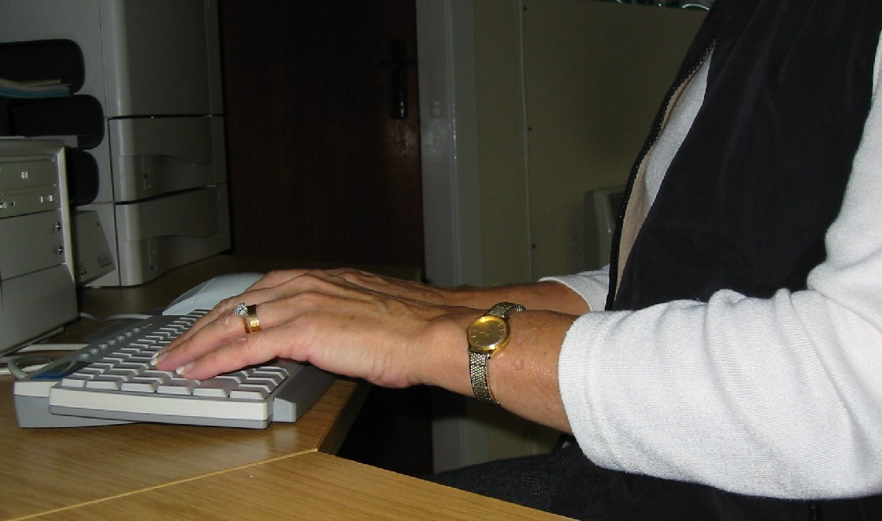  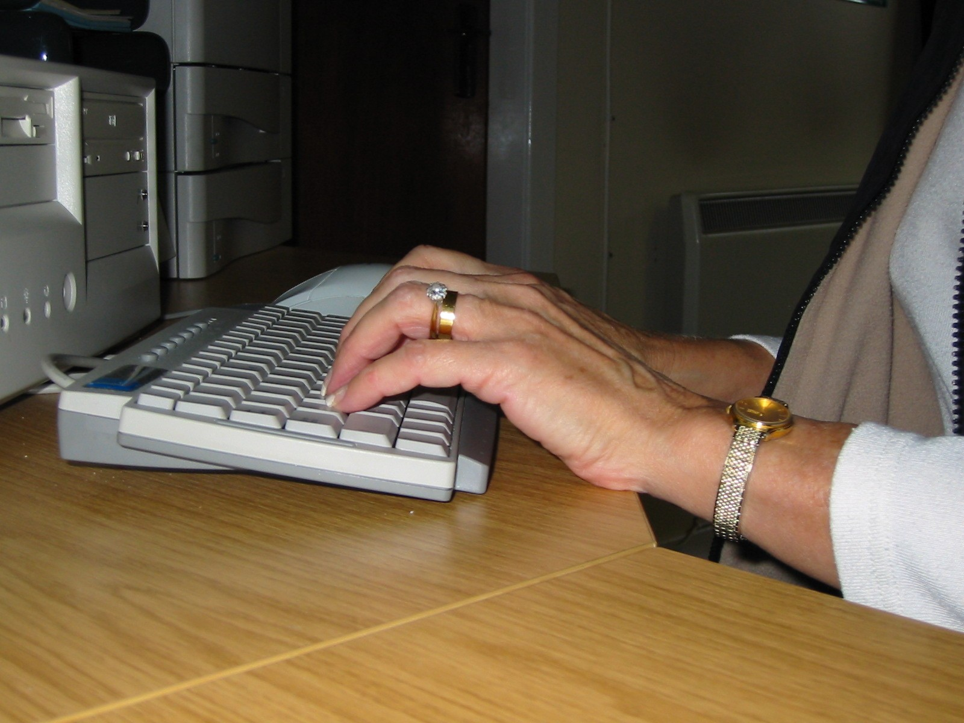  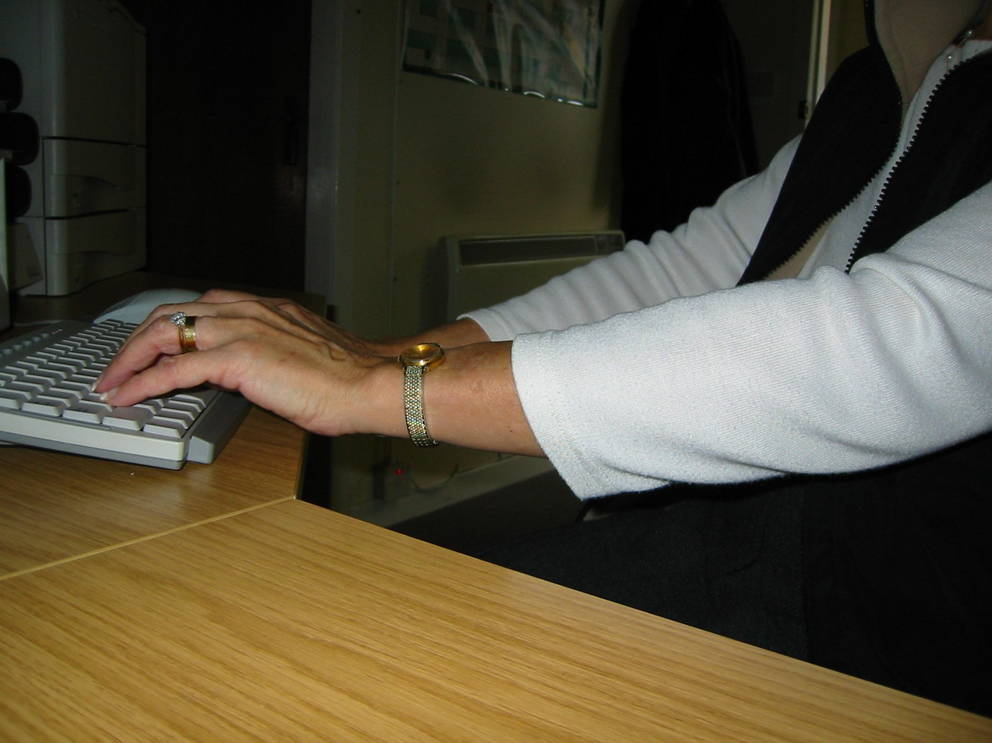 |  |  | Try pushing the display screen further back to create more room for the keyboard, hands and wrists.  Keep elbows close to the body, do not overstretch the arms.  Users of thick, raised keyboards may need a wrist rest.
Does the user have good keyboard technique? |  |  | Keyboard training can help prevent:  hands bent up at wrist  hitting the keys too hard  overstretching the fingers
Are the characters on the keys easily readable? |  |  | Keyboards should be kept clean. If characters still cannot be read, the keyboard may need modifying or replacing.  Use a keyboard with a matt finish to reduce glare and/or reflection.
MOUSE

Is the device positioned close to the user?  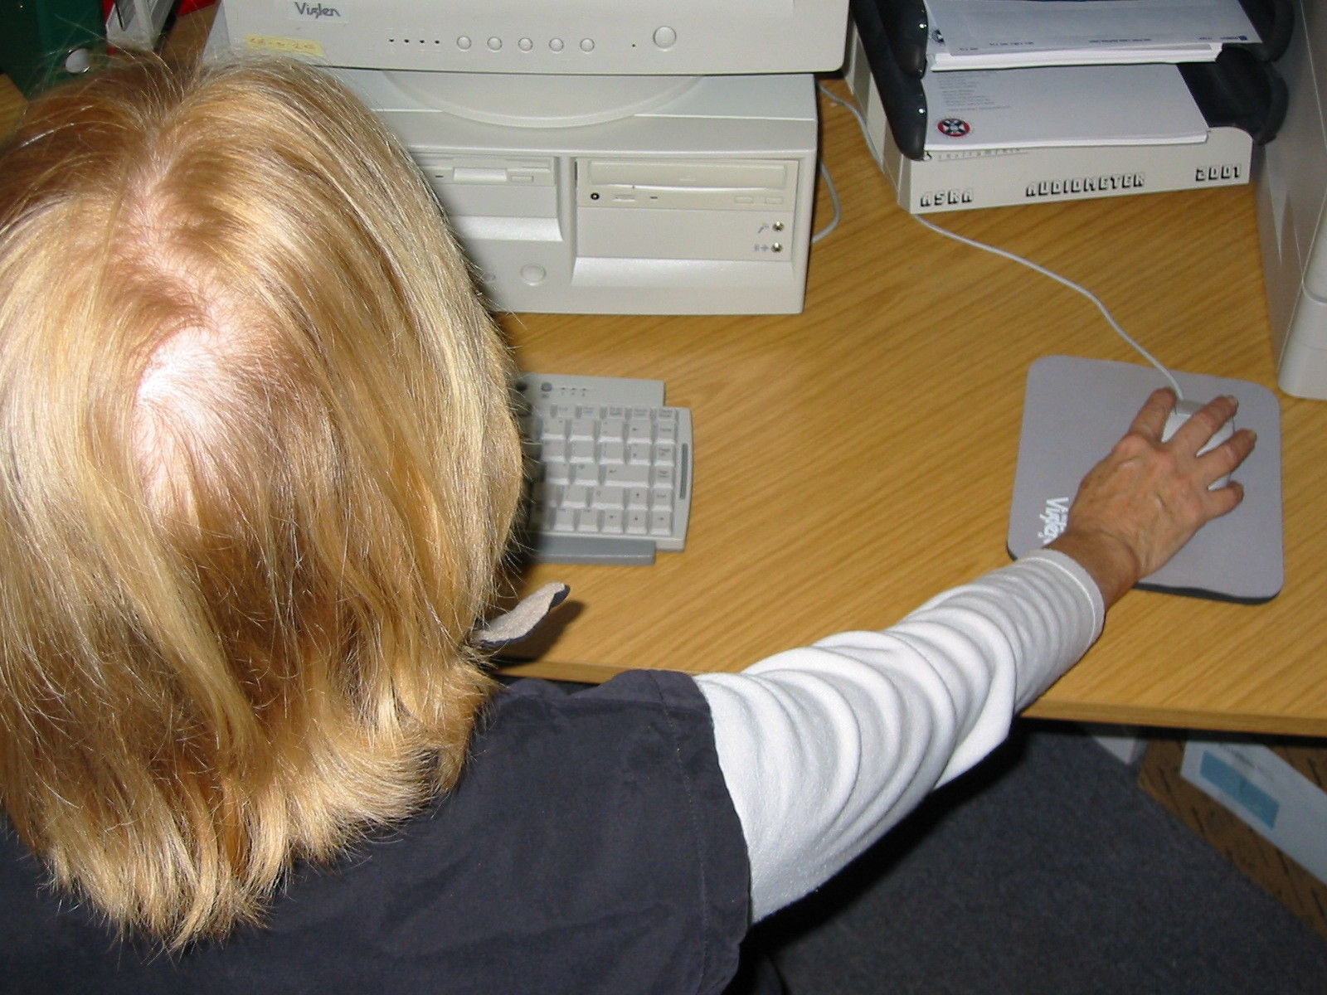  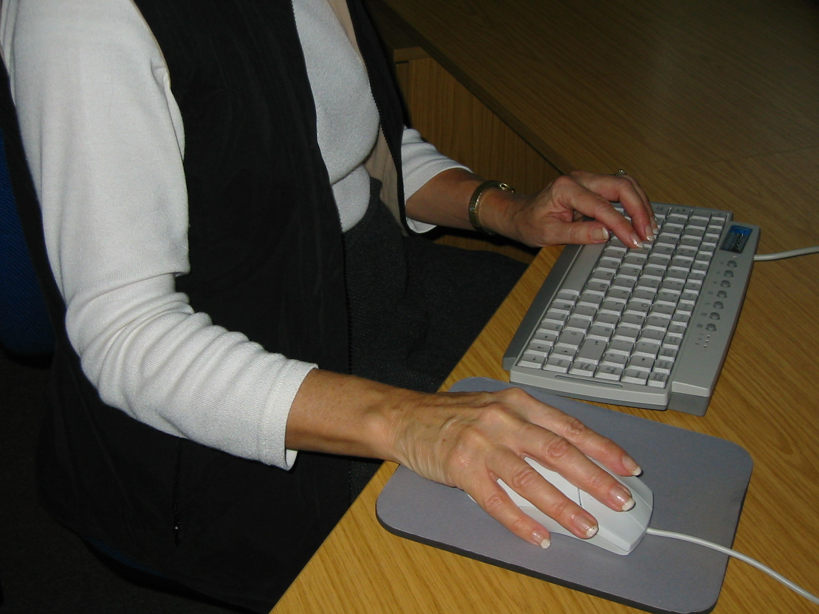 |  |  | Most devices are best placed as close as possible, e.g. right beside the keyboard.  Ask the user to demonstrate how they use the device. Look to ensure that:  the arm is not over-reaching  the arm is relaxed and the wrist straight  the user does not leave their hand on the device when it is not being used  Consider issuing guidance booklet and/or recommending further training if necessary.
Is the device suitable for the tasks it is used for? |  |  | If the user is having problems, try a different device. The mouse and trackball are general-purpose devices suitable for many tasks, and available in a variety of shapes and sizes.  Alternative devices such as touch screens may be better for some tasks (but can be worse for others).  Check the device has been set to suit the user (for right or left hand user).
Risk Factors | Please tick |  | Things for assessor to consider | Action to take
MOUSE (Continued) | YES | NO
Is there support for the user’s wrist and forearm when using the device? |  |  | Support can be gained from the desk surface or armrest of a chair. If not, a separate supporting device may help.  The user should be able to find a comfortable working position with the device. The user may benefit from having a wrist rest.
Does the device work smoothly at a speed that suits the user? |  |  | Check if cleaning is required (e.g. of mouse ball and rollers).  Check the work surface is suitable. A mouse mat may be needed.
Can the user easily adjust software settings for speed and accuracy of pointer? |  |  | Users may need training in how to adjust device settings.
SOFTWARE

Is the software suitable for the task? |  |  | Software should help the user carry out the task, minimise stress and be user-friendly.  Has the user had appropriate training in using the software.  Software should respond quickly and clearly to user input, with adequate feedback, such as clear messages.
FURNITURE

Is the work surface large enough for all the necessary equipment, papers etc? |  |  | Create more room by moving reference materials etc elsewhere. Use multilevel trays for papers/documents.  If necessary, consider recommending new power and telecom sockets, so equipment can be moved.
Can the user comfortably reach all the equipment and papers they need to use? |  |  | Rearrange equipment, papers etc to bring frequently used things within easy reach.  A document holder may be needed, positioned to minimise uncomfortable head and eye movements.
Are surfaces free from glare and reflection? |  |  | Consider mats or blotters to reduce reflections and glare.
Is the chair stable & suitable for the user?  Does the chair have a working:  seat back height and tilt adjustment?  Seat height adjustment?  Swivel mechanism?  Castors or glides? |  |  | The chair may need repairing or replacing if the user is uncomfortable, or the adjustment mechanisms are faulty or absent.
Risk Factors | Please tick |  | Things for assessor to consider | Action to take
FURNITURE (Cont) | YES | NO
Is the chair adjusted correctly? |  |  | The user must be familiar with the chair adjustments.  Adjust the chair height to sit with elbows at approx. 90º & 2cm above the desk when touching the G & H keys.  Make sure the user can rest their feet on the floor. A foot rest will be necessary if this is not possible.  Consider training the user in how to adopt suitable postures while working.  Armrests on chairs can stop the user getting close enough to use the computer comfortably. Consider chairs without armrests, having armrests removed or, alternatively, chairs with adjustable armrests.  Move any obstructions from under the desk.
Is the lower back supported by the chair’s backrest? |  |  | The user should have a straight back, supported at all times by the chair, with relaxed shoulders.
Are forearms horizontal and eyes at roughly the same height as the top of the screen? |  |  | Adjust the chair height to get the user’s arms in the right position; adjust the monitor height / tilt if necessary.
ENVIRONMENT

Is there enough room to change position and vary movement? |  |  | Space is needed to move, stretch and fidget.  Cables should be tidy and not a trip or snag hazard.
Is the lighting suitable, e.g. not too bright or too dim to work comfortably? |  |  | Users should be able to control light levels, e.g. by adjusting window blinds or light switches.  Consider shading or repositioning light sources or providing local lighting, e.g. desk lamps (but make sure lights don’t cause glare by reflecting off walls or other surfaces).
Does the air feel comfortable? |  |  | VDUs and other equipment may dry the air. Green plants may help to increase moisture levels in the air.  Circulate fresh air if possible.  As a last resort, if discomfort is severe, consider recommending a humidifier.
Are levels of heating comfortable? |  |  | Can heating be better controlled? More ventilation or air-conditioning may be required if there is a lot of electronic equipment in the room. Or, can users be moved away from the heat source?
Are levels of noise comfortable? |  |  | Consider moving sources of noise, e.g. printers, away from the user. If not, consider soundproofing.

Section 3 – Actions and Recommendations

Action taken during the assessment:
Assessor’s Comments:

Action to be taken:
 | Priority  H, M, L | To be actioned by: (e.g. Office Manager/Line Manager/User): | Action taken  (sign & date)

Signatures: I confirm that this reflects the assessment undertaken.
User: |  | Date:
Assessor: |  | Date:

Signatures: I confirm that the actions detailed above have now been completed.
Line Manager: |  | Date:

Appendix B – Responsibilities Checklist

This list is meant to remind people of their main responsibilities and may not be exhaustive. It is not an alternative to reading the policy document in detail.

Everyone should:

Follow common sense in all health and safety matters
Keep stage clean and tidy
Not move any large or heavy objects unless they feel safe to do so.
Take care to lay stage blocks and other items likely to fall on the ground
Keep storage areas tidy
Record any damage in the damage book
Book rooms they wish to use with Administrator
Leave rooms how they are found, or better
Only use your own keys
Keep the church clean and tidy
Not smoke in the building
Not put up signs on the walls. Use the notice boards instead
Inform Fire Officer when a fire extinguisher has been used
Keep fire exits clear at all times
Keep fire doors closed and passageways clear
Be familiar with the Evacuation procedure in the event of a fire
Not use naked flames in the building, other than birthday cake candles, advent candelabra, Christingles or similar; adult supervision required at all times.
Record all accidents in book provided. Report in person if serious
Be aware of the food hygiene regulations if they regularly prepare food
Not use electrical items with broken plugs or frayed cables
Ensure all personal electrical equipment is safe
Ensure cables are safe and won’t cause trips or falls
Use ear plugs if you’re doing something loud!
Wear eye guards if there’s a chance of something getting in their eyes

Event Organiser / Activity Leaders should:

Take a register of all youth activities (and roll call in event of a fire)
Maintain clear escape routes
Ensure chairs are stacked away after use
Perform risk assessments for Work Days
Make special consideration of health and safety issues for one-off or new events
Lock up afterwards
Ensure Bouncy Castle is supervised
Take first aid kits on trips away
Consider having a trained first aider in the group
Lock doors, block access to dangerous areas and check for slip/trip hazards for children’s activities
Tape down all cables across walkways or doors

The Health and Safety officers should:

Distribute Health and Safety guidelines and give briefings
Conduct an Annual Risk Assessment
Provide and maintain First Aid Kits
Review accidents and report to BU if necessary

Staff should:

Lock up if they are the last to leave.
Complete a Display Screen Assessment form

The Administrator should:

Take responsibility for Health and Safety Officer in Health and Safety Officer’s Absence
Co-ordinate bookings for the building
Review accidents and report to BU if necessary
Conduct or organise PAT testing of electrical equipment

The Pastor should:

Review serious accidents and report to BU if necessary

The Cleaner should:

Run the showers for 5 minutes per week

Appendix C – Health and Safety Briefing Checklist

“All new staff and activity leaders must read these guidelines on joining. They will also be given a Health and Safety briefing by the Health and Safety officer or Administrator.” (Summary Statement, 1.0)

This initial briefing should cover the following areas:

Summary: Who is responsible for Health and Safety (Health and Safety officers/Administrator). Concerns should be reported to them in writing. Each staff member is required to act in a safe manner. Health and Safety is mostly common sense.

Fire: Where fire fighting equipment is and where fire exits are. The importance of unlocking and keeping fire exits clear. Registers. Evacuation procedure and fire drills. No naked flames in building, other than birthday cake candles, advent candelabra, Christingles or similar - all with adult supervision.

Equipment: Stacking chairs, aisles. Stage blocks and other items likely to fall, ladder (only trained people). Manual handling (only building team), storage (what’s where), insurance (personal items not covered).

Events: How to book the church (Administrator), “leave it how you find it” policy, new events assessment. Leader responsible for H&S unless someone else appointed.

Building Use: Keys (they are for one person, misc keys), showers or sleepovers, what’s cleaned when and where the cleaning supplies are (including toilet rolls). Where the bin is. Recycling. Heating programmed (where it is – no access). No Smoking. Signage (no blu tak!)

General Health and Safety: First Aid Kits, Accident Reporting, Children (Locking Doors), Kitchen Basic Hygiene Rules and agreed procedures, Electrics (frayed cables, broken plugs, taping down cables, plug guards, stay away from trips), Cordon off Dangerous Areas, Ear Plugs, Eye Tests.

Safeguarding – separate policy

Personal Declaration
Woodville Christian Centre

Health, Safety and Building Management Policies

Personal Declaration

Each member of staff, leader or building user must read, understand and note their responsibilities for Health and Safety contained in this policy document.

In order to ensure that each person actually does read and acknowledge their responsibilities we ask everyone to complete the declaration below and return it to the church’s Health and Safety Officer.

Your Name:

I have read, understood and noted my responsibilities as a user of Woodville Christian Centre as detailed in the “Health, Safety and Building Management Policies” document.

Signed: Date:

